WEB TECHNOLOGY LAB
EXP.NO: 6
DATE: 23/03/2026

AIM:
To demonstrate session tracking using HttpSession in a Servlet-based web application by implementing a simple login system.

ALGORITHM:
1. Input:
The user enters username and password through a login form.
2. Steps:
1. Create an HTML login form with username and password fields.
2. Create a Login Servlet to handle user requests.
3. Retrieve user inputs using request.getParameter().
4. Validate credentials (hardcoded or database).
5. If valid:
- Create a session using HttpSession.
- Store username using session.setAttribute().
6. Redirect to a protected page (Home page).
7. If invalid:
- Show error message or redirect to login page.
8. Implement logout functionality using session.invalidate().
9. Handle session expiration if user is inactive.

PROGRAM:

1. HTML Login Page (login.html)
<!DOCTYPE html>
<html>
<head>
<title>Login Page</title>
</head>
<body>
<h2>Login</h2>
<form action="LoginServlet" method="post">
Username: <input type="text" name="username"><br><br>
Password: <input type="password" name="password"><br><br>
<input type="submit" value="Login">
</form>
</body>
</html>

2. Login Servlet (LoginServlet.java)
import java.io.*;
import javax.servlet.*;
import javax.servlet.annotation.WebServlet;
import javax.servlet.http.*;
@WebServlet("/LoginServlet")
public class LoginServlet extends HttpServlet {
protected void doPost(HttpServletRequest request, HttpServletResponse response)
throws ServletException, IOException {
response.setContentType("text/html");
PrintWriter out = response.getWriter();
String username = request.getParameter("username");
String password = request.getParameter("password");
if(username.equals("admin") && password.equals("1234")) {
HttpSession session = request.getSession();
session.setAttribute("username", username);
session.setMaxInactiveInterval(300);
response.sendRedirect("home");
} else {
out.println("<h3>Invalid Username or Password</h3>");
}
}
}

3. Home Servlet (HomeServlet.java)
import java.io.*;
import javax.servlet.*;
import javax.servlet.annotation.WebServlet;
import javax.servlet.http.*;
@WebServlet("/home")
public class HomeServlet extends HttpServlet {
protected void doGet(HttpServletRequest request, HttpServletResponse response)
throws ServletException, IOException {
response.setContentType("text/html");
PrintWriter out = response.getWriter();
HttpSession session = request.getSession(false);
if(session != null && session.getAttribute("username") != null) {
String user = (String) session.getAttribute("username");
out.println("<h2>Welcome " + user + "</h2>");
out.println("<a href='LogoutServlet'>Logout</a>");
} else {
response.sendRedirect("login.html");
}
}
}

4. Logout Servlet (LogoutServlet.java)
import java.io.*;
import javax.servlet.*;
import javax.servlet.annotation.WebServlet;
import javax.servlet.http.*;
@WebServlet("/LogoutServlet")
public class LogoutServlet extends HttpServlet {
protected void doGet(HttpServletRequest request, HttpServletResponse response)
throws ServletException, IOException {
HttpSession session = request.getSession(false);
if(session != null) {
session.invalidate();
}
response.sendRedirect("login.html");
}
}

OUTPUT:

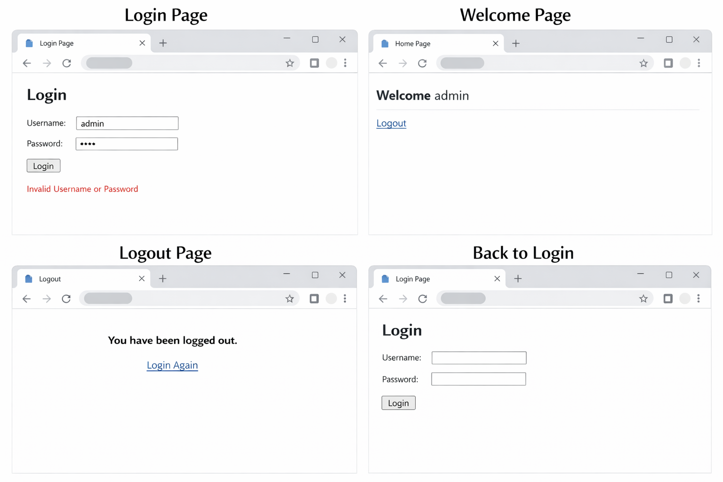

RESULT:
A Servlet-based web application is successfully created to demonstrate session tracking using HttpSession.

